**ACCIDENT LOCATIONS ON INDIAN ROADS-**

**A report based on the study of Tamil Nadu roads.**

Aaron Thomas Blessen, Dr. Anju Pratap

Department Of Computer Science and Engineering

Saintgits College Of Engineering, Kerala

Abstract:- This project showcases the most accident-prone areas in certain parts of Tamil Nadu.

These locations were found by analyzing the Tamil Nadu road accident data. By analyzing the program output, we can also understand the speed, time, and months, at which most Accidents took place.

1. Introduction

India ranks first in the world for the number of accidents and lives lost on the roads. The country has only 1% of vehicles worldwide but has 11% of accidents worldwide. The Ministry of Road Transport (MoRTH) uses the concept of a Blackspot to mark these locations to improve road safety on national highways in the country. Moreover, States and local authorities also maintain a similar list of accident locations on road networks – typically with location names.

Road accident prediction is a significant area of research in traffic safety. Several factors influence the likelihood of road traffic accidents, including the geometric characteristics of the road, traffic flow patterns, weather conditions, time of occurrence, driver characteristics, and the overall road environment.

1. Problem Definition

The exponential growth of vehicles and accidents poses a pressing concern for road safety. It is imperative to take decisive measures to effectively address this issue in our country. Although various solutions exist, their proper implementation has been lacking thus far.

1. Proposed Solution

The solution involved utilizing a time series dataset of accidents in Tamil Nadu, which provided more specific details and contained over 21,000 entries after undergoing data cleaning. The ward names were found using the K-nearest Neighbor Classifier, using another dataset that consisted of Tamil Nadu ward data. This enriched dataset included specific details such as vehicle speed, accident timing, date of occurrence, and the type of accidents involved.

1. Methodology

The geographic area of Tamil Nadu was specifically chosen for analysis in this project. The main objective is to identify the most accident-prone locations within certain parts of Tamil Nadu.

The dataset used for analysis was provided by the Intel Unnathi Grand Challenge Team. Subsequently, data cleaning procedures were performed, including null value removal, data imputation, deletion of duplicate data, and other necessary steps. The project aims to go beyond identifying accident-prone locations by also analyzing factors such as the time of day, date, months, and speed at which accidents are most likely to occur in Tamil Nadu. A machine-learning model, specifically the K Nearest Neighbor Classifier was developed using training data to address missing values. This comprehensive approach combines machine learning, data analysis, to gain insights into accident-prone areas, timing, and other relevant factors within Tamil Nadu.

1. Analysis and interpretation

Based on the data analysis model, it has been determined that Madipakkam, Acharapakkam West and Ganesh Nagar are the most dangerous areas in Tamil Nadu in terms of road accidents. The average speed at which most accidents occur is approximately 38.65 km/h. Additionally, the analysis revealed that the months of June and August have the highest number of accidents. Regarding the distribution of accidents throughout the week, there is a consistent trend except for Saturday and Sunday, with Sunday having the lowest number of accidents. Furthermore, the hours of the day that exhibit noticeable variations in the number of accidents are from 5:00 am to 8:00 am and from 3:00 pm to 6:00 pm. These time periods are considered the most dangerous times to be on the roads in Bangalore. It's important to note that the above information is based on the data analysis conducted, and the provided details reflect the findings related to accident-prone areas, speed, months, days of the week, and specific hours in Tamil Nadu.

Figure(i)

Figure(ii) Figure(iii)

Figure(iv) Figure(v)

Figure(vi) Figure(vii)

Figure(viii) Figure(ix)

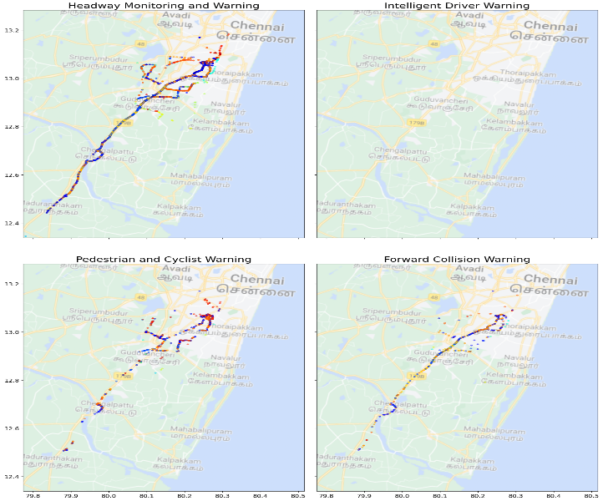

Figure(x) Figure(xi)

1. Conclusions

This project successfully analyzed road accident data in Tamil Nadu and found the most accident-prone areas in the city. By utilizing data analysis techniques, valuable insights were gained regarding the locations, speed, timing, and months when accidents are most prevalent. The findings of this project highlight the urgent need to address road safety concerns in Tamil Nadu and implement effective measures to reduce accidents and ensure the well-being of road users. The identification of specific accident-prone areas, such as Madipakkam, Acharapakkam West and Ganesh Nagar, provides valuable information for targeted interventions and improvements in these locations.

Furthermore, understanding the factors that contribute to accidents, such as the average speed of around 38.65 km/h, the months of June and August witnessing higher accident rates, and the specific time periods of heightened risk during morning and evening commute hours, enables authorities to devise strategies to enhance road safety during these critical periods. Overall, this project demonstrates the importance of data analysis and machine learning in understanding and addressing road safety challenges. It sets the foundation for evidence-based interventions, improved traffic planning, and ultimately a safer environment for all road users in Tamil Nadu.

1. Future

This project has the potential to extend beyond Tamil Nadu and encompass other cities or regions in India. By analyzing road accident data and creating maps for multiple areas, the project can contribute to a comprehensive understanding of road safety challenges on a larger scale. To enhance its impact, the project can explore the integration of real-time data sources, such as traffic cameras, sensors, and social media feeds. This integration would enable live monitoring of road conditions and accident occurrences, providing valuable insights for immediate response and proactive accident prevention measures.

Moreover, building upon the existing machine learning model, the project can develop predictive analytics capabilities. By leveraging historical accident data and considering factors like weather conditions, traffic volume, and road infrastructure, the model can forecast accident-prone areas and times. This would enable authorities to take preemptive actions and implement targeted safety measures. To maximize the project's reach, integration with platforms like Google Maps could be considered. By alerting travelers about specific accident-prone locations, the project can enhance user awareness and contribute to safer journeys. Additionally, regularly sharing this information with the police department can aid them in enforcing road safety measures effectively. By embracing these future directions, the project can continue making a significant impact on improving road safety, reducing accidents, and saving lives. By fostering a culture of safety and contributing to a sustainable transportation system in India, this project can drive positive change for road users nationwide.

1. References

<https://github.com/Aaron-Thomas-Blessen/intelunnati_grandchallenge_Aaronthomas.git>

<https://github.com/sanand0/pincode/blob/master/data/IN.csv>